Contents

Report on Life skill Workshop 1

FYIT-28 1

Day1 1

Session 1- 1

Session 2- 1

Session 3- 1

Day 2 1

Session 1- 1

Session 2 1

Session 3 2

Day 3 2

Session 1- 2

Session 2- 2

Session 3- 2

Review 2

GREEN TECHNOLOGY 3

Open Source Software 5

What is free software? 5

The four essential freedoms 6

Rules about packaging and distribution details 6

Export regulations 7

Legal considerations 7

Beyond Software 7

Open Source? 7

Difference between Free Software and Proprietary Software 8

# Report on Life skill Workshop

# FYIT-28

## Day1

### Session 1-

There was the introduction of our soft skill mentor Dr. Sujatta. R .Singhii, who was an international speaker .Then we started the workshop by grouping the participants. Then we had an action song known as follow the leader. After that we got a task to do advertising of products.

### Session 2-

In the second session we have the advertising of the products, in which we had to do marketing of a product, but we had to transform the product into a new product. Many of the participants came up with different and funny ideas. Then we had the song follow the leader which made everyone energetic.

### Session 3-

In the third session which was after the tea break we have Dr. Sujatta ma’am who taught us the importance of gratitude and we should always be thankfully to our parent for all the sacrifices they have done for us, just to fulfil our needs. Then by the end of the session we were told to give roses to our parents because for all the sacrifices they have done for us.

## Day 2

### Session 1-

On the second day of the workshop we started the workshop with an action song known as ‘follow the leader’ which made everyone very energetic. Everyone got a chance to go on stage and get out their stage fear.

### Session 2

In the second session we had to make a spaceship for the princess, by using chart paper, sketch pens, straws etc. And the spaceship should be a 3D modal and at least 3feet in height and length. The spaceship must contain a bedroom, kitchen and all the amenities that the princess will need to live.

### Session 3

In this session we had the rock star event in which we had to go on the stage and dance individually. Many of the people got comfortable on the stage.

## Day 3

### Session 1-

On the third day of the workshop we again started with the action song ‘follow the leader ‘. Then we made a chart known as ‘my vision board’. In which everyone put their vision of what they wish to be in future. The new had a certification for every student of the workshop. At the end of every workshop we had an action song again ‘follow the leader’.

### Session 2-

She performed to us Healing therapy of sound using Himalayan bowls to create an ethereal ambiance.

### Session 3-

Finally, the day ended by us receiving our certificates and dancing and singing all the way home.

## Review

Till now, it was one of the best experience I had in my life. It was amazing, I enjoyed every single moment. From this workshop I get to learn many things like to control my anger and always follow a leader and try to be one. And, the rock star part was my favourite and it was very fun and joyful event. I thanks my teacher and principle for holding this workshop.

# GREEN TECHNOLOGY

Green technology, also known as sustainable technology, takes into account the long- and short-term impact something has on the environment….. Energy efficiency, recycling, health and safety concerns, renewable resources, and more all go into the making of a green product or technology.

Green technology includes the conversion of renewable resources, such the suns light, wind and water to energy that we can use. Solar panels, wind turbines and geothermal wells are all examples of technological innovations that can replace the need for coal and oil.

Green technology aims to minimize the negative impact of IT operations on the environment by designing, manufacturing, operating and disposing of computers and computer-related products in an environmentally-friendly manner. The motives behind green IT practices include reducing the use of hazardous materials, maximizing energy.

The most important benefit of green building is that which it offers to our environment. It positively influences our climate and overall ecosystem by reducing water use and energy sources that pollute our environment, such as coal and carbon dioxide discharged into the atmosphere.

Many IT manufacturers and vendors are continuously investing in designing energy-efficient computing devices, reducing the use of dangerous materials and encouraging the recyclability of digital devices. Green computing practices came into prominence in 1992, when the Environmental Protection Agency (EPA) launched the Energy Star program.

Green computing aims to attain economic viability and improve the way computing devices are used. Green IT practices include the development of environmentally sustainable production practices, energy-efficient computers and improved disposal and recycling procedures.

To promote green computing concepts at all possible levels, the following four approaches are employed:

Green use: Minimizing the electricity consumption of computers and their peripheral devices and using them in an eco-friendly manner

Green disposal: Repurposing existing equipment or appropriately disposing of, or recycling, unwanted electronic equipment

Green design: Designing energy-efficient computers, servers, printers, projectors and other digital devices

Green manufacturing: Minimizing waste during the manufacturing of computers and other subsystems to reduce the environmental impact of these activities

Average computer users can employ the following tactics to make their computing usage greener:

Use the hibernate or sleep mode when away from a computer for extended periods

Buy energy-efficient notebook computers, instead of desktop computers

Activate the power management features for controlling energy consumption

Make proper arrangements for safe electronic waste disposal

Turn off computers at the end of each day

Refill printer cartridges, rather than buying new ones

Instead of purchasing a new computer, try refurbishing an existing device

# Open Source Software

**FYIT-28**

## What is free software?

“Free software” means software that respects users' freedom and community. Roughly, it means that **the users have the freedom to run, copy, distribute, study, change and improve the software**. Thus, “free software” is a matter of liberty, not price. To understand the concept, you should think of “free” as in “free speech,” not as in “free beer”. We sometimes call it “libre software,” borrowing the French or Spanish word for “free” as in freedom, to show we do not mean the software is gratis.

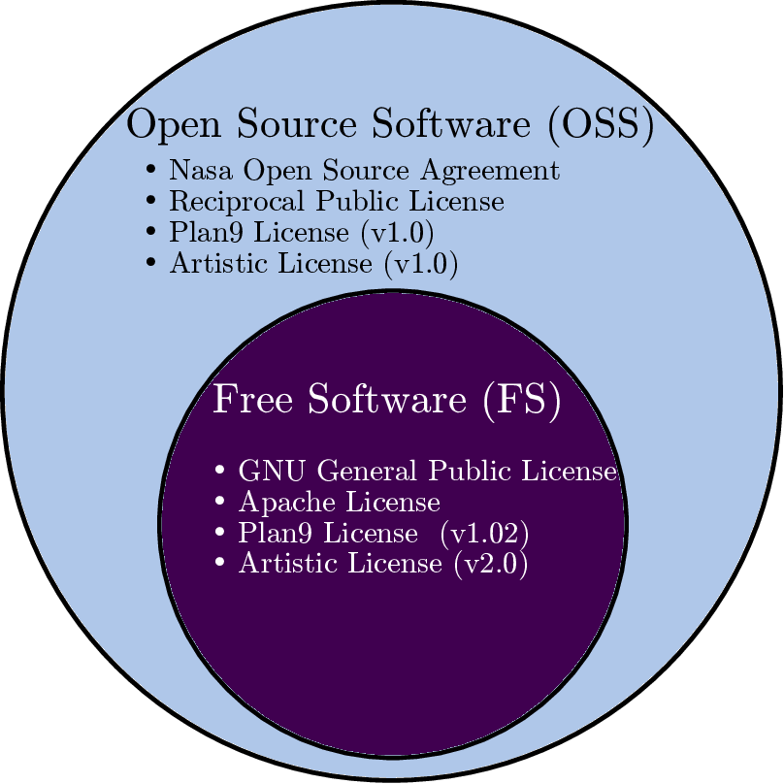

We campaign for these freedoms because everyone deserves them. With these freedoms, the users (both individually and collectively) control the program and what it does for them. When users don't control the program, we call it a “nonfree” or “proprietary” program. The nonfree program controls the users, and the developer controls the program; this makes the program [an instrument of unjust power](https://www.gnu.org/philosophy/free-software-even-more-important.html).

## The four essential freedoms

* A program is free software if the program's users have the four essential freedoms:
* The freedom to run the program as you wish, for any purpose.
* The freedom to study how the program works, and change it so it does your computing as you wish. Access to the source code is a precondition for this.
* The freedom to redistribute copies so you can help others.
* The freedom to distribute copies of your modified versions to others. By doing this you can give the whole community a chance to benefit from your changes. Access to the source code is a precondition for this.

## Rules about packaging and distribution details

Rules about how to package a modified version are acceptable, if they don't substantively limit your freedom to release modified versions, or your freedom to make and use modified versions privately. Thus, it is acceptable for the license to require that you change the name of the modified version, remove a logo, or identify your modifications as yours. As long as these requirements are not so burdensome that they effectively hamper you from releasing your changes, they are acceptable; you're already making other changes to the program, so you won't have trouble making a few more.

## Export regulations

Sometimes government export control regulations and trade sanctions can constrain your freedom to distribute copies of programs internationally. Software developers do not have the power to eliminate or override these restrictions, but what they can and must do is refuse to impose them as conditions of use of the program. In this way, the restrictions will not affect activities and people outside the jurisdictions of these governments. Thus, free software licenses must not require obedience to any nontrivial export regulations as a condition of exercising any of the essential freedoms.

## Legal considerations

In order for these freedoms to be real, they must be permanent and irrevocable as long as you do nothing wrong; if the developer of the software has the power to revoke the license, or retroactively add restrictions to its terms, without your doing anything wrong to give cause, the software is not free.

A free license may not require compliance with the license of a nonfree program. Thus, for instance, if a license requires you to comply with the licenses of “all the programs you use”, in the case of a user that runs nonfree programs this would require compliance with the licenses of those nonfree programs; that makes the license nonfree.

## Beyond Software

[Software manuals must be free](https://www.gnu.org/philosophy/free-doc.html), for the same reasons that software must be free, and because the manuals are in effect part of the software.

The same arguments also make sense for other kinds of works of practical use — that is to say, works that embody useful knowledge, such as educational works and reference works. [Wikipedia](http://wikipedia.org/) is the best-known example.

## Open Source?

Another group uses the term “open source” to mean something close (but not identical) to “free software”. We prefer the term “free software” because, once you have heard that it refers to freedom rather than price, it calls to mind freedom. The word “open” [never refers to freedom](https://www.gnu.org/philosophy/open-source-misses-the-point.html).

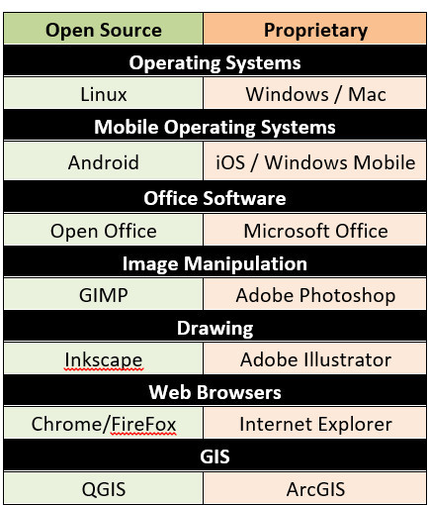

## Difference between Free Software and Proprietary Software

|  |  |
| --- | --- |
| Free Software | Proprietary Software |
| Purchased with its source code | Purchased without its source code |
| User can get open software for free of charge | Users must pay to get the proprietary software |
| Users can modify the software | Users cannot modify the software |
| Users can install software freely into any computer | User must have a license from vendor before install into computer |